**The 2 group mystery**

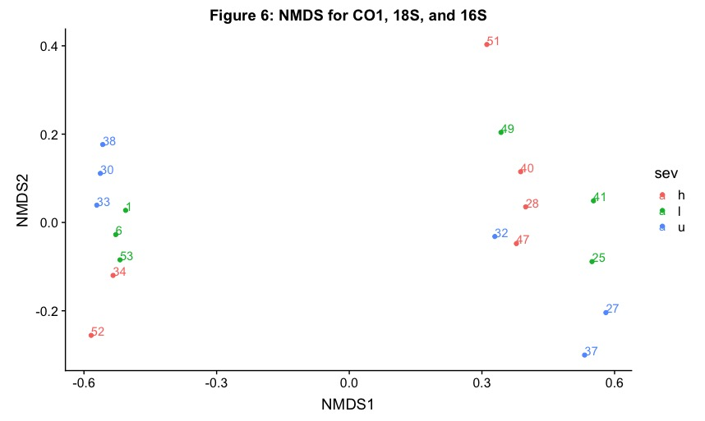

CO1, 18S, and 16S all show this same pattern when analyzed separately. The same samples consistently fall into the same group. Fire severity seems to have an effect within each group, but that effect is clearly dwarfed by the difference between groups. An indicator analysis (not shown) clearly shows numerous species being associated with one or the other of the groups, but there is no obvious geographic or ecological distinction between them!